DevOps Final Project

Topic: PDF Merger Website

DEMO WEBSITE: <https://devops-project-pdf-merger.onrender.com/merge.html>

Submitted by: Evan Ferrao

Register Number: 23BAI1262

Email: [evan.ferrao2023@vitstudent.ac.in](mailto:evan.ferrao2023@vitstudent.ac.in)

GitHub Link: <https://github.com/evanferrao/devops-project-pdf-merger>

Tools Used: Java, Maven, Git, Puppet, Docker, Ansible, Graphite, Grafana, Jenkins.

Project summary

This project involved building and deploying a Java-based PDF Merger web application using a complete DevOps pipeline. The application, developed with Spring Boot, allows users to upload and merge PDF files through a browser interface. Maven was used for building the application and managing dependencies.

Version control was managed with Git, and Jenkins was configured to automatically build and deploy the project on code push. The Jenkins pipeline included steps for code checkout, Maven build, unit testing, and deployment via Ansible. Initially, Puppet was used to demonstrate service setup, later replaced by a Docker-based deployment.

The application was containerized using Docker, and Ansible automated the process of copying files, building the image, and running the container. Metrics such as merge count, duration, and memory usage were exported using Micrometer and StatsD, collected by Graphite, and visualized with Grafana.

The project demonstrates a streamlined CI/CD workflow covering build automation, deployment, containerization, and monitoring.

Step 1: Building the Java Application

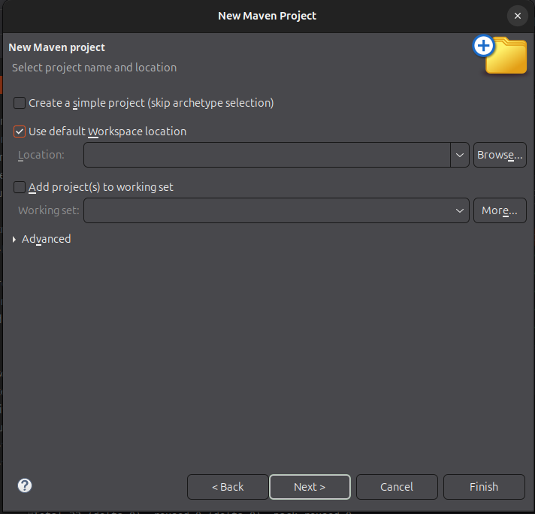

Creating a new Eclipse Project

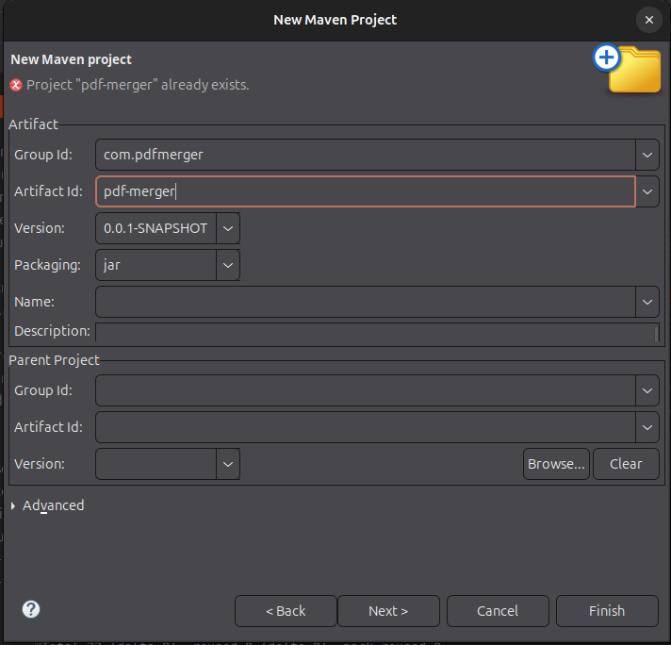

Giving the Project the name ‘pdf-merger’

Step 2: Defining the Java Project in Eclipse

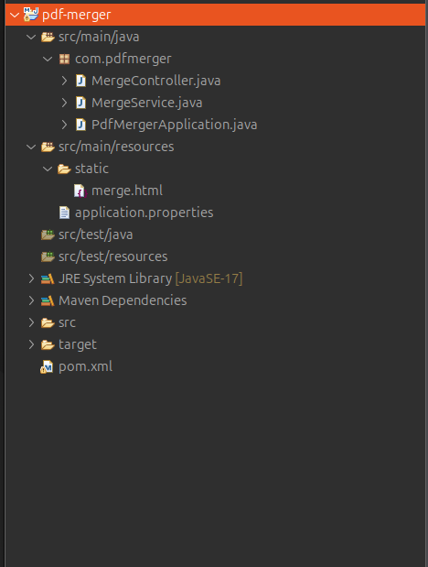

Project Structure in Eclipse

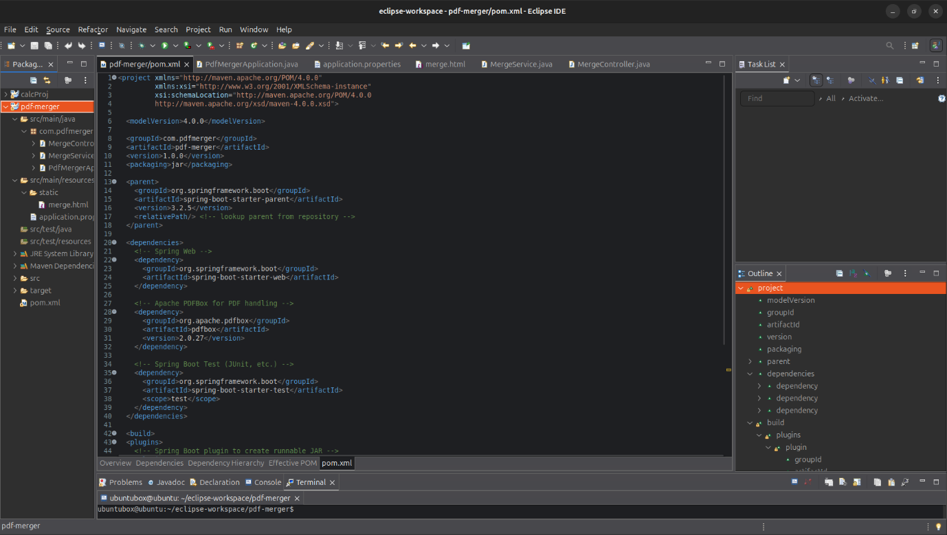

Details of pom.xml

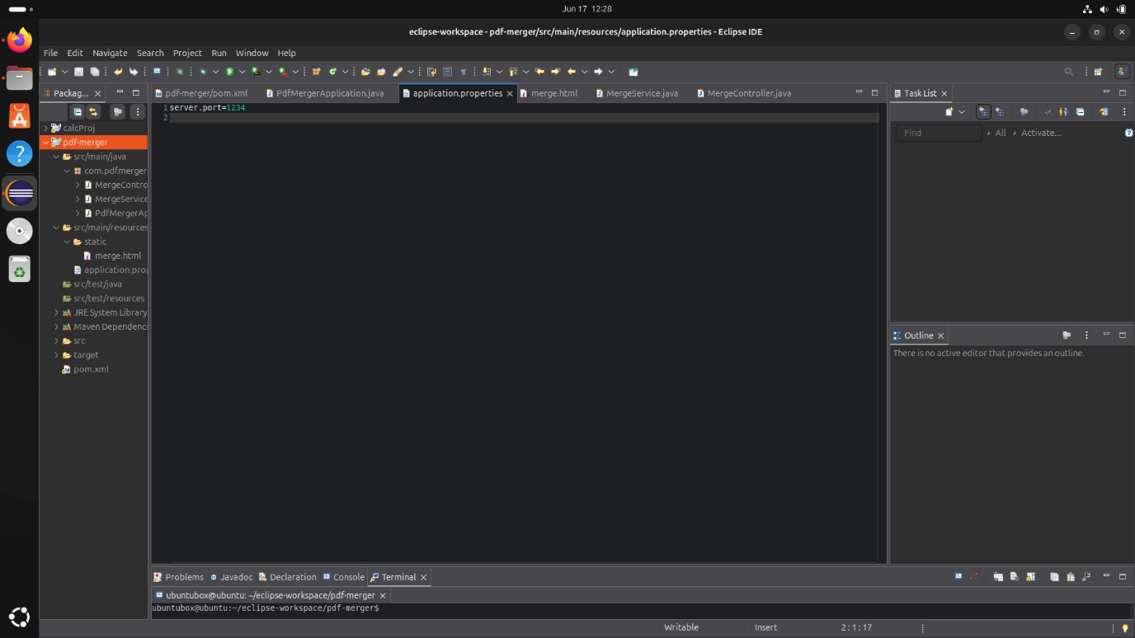

Details of application.properties

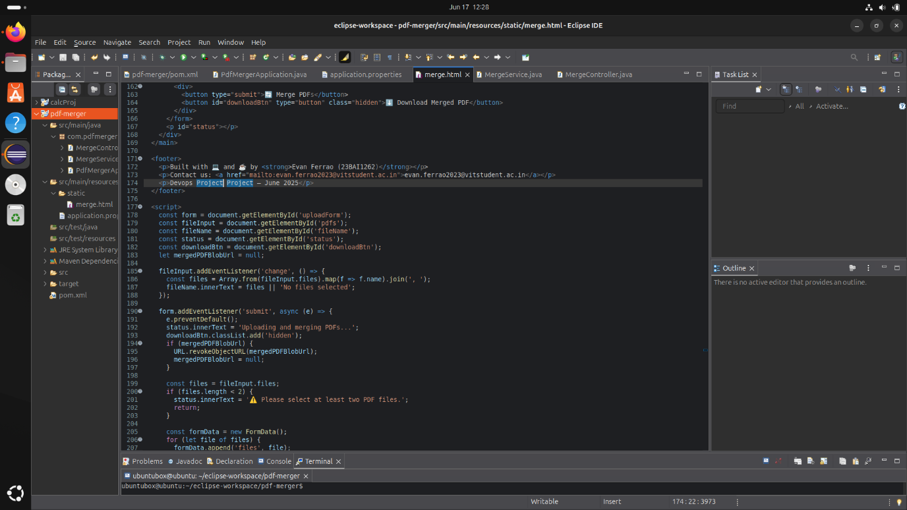

Details of merge.html (used for UI)

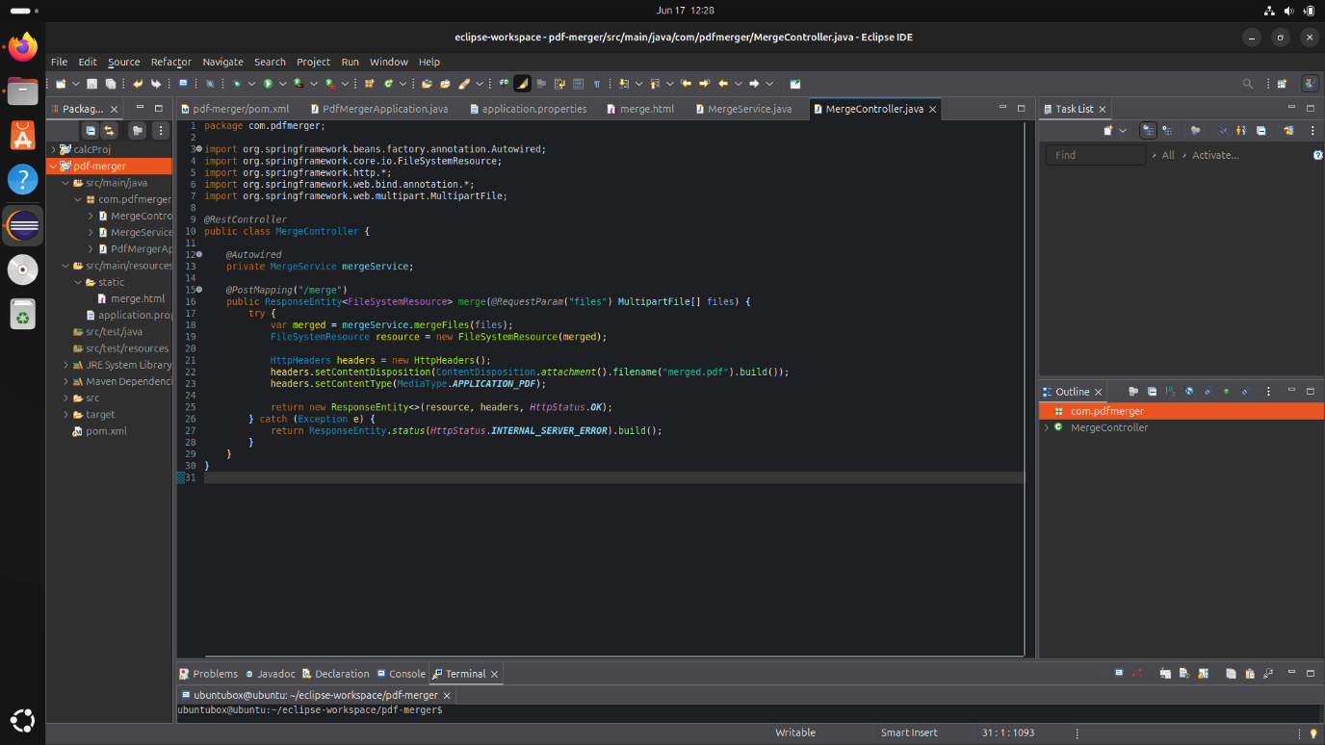

Details of MergeController.java

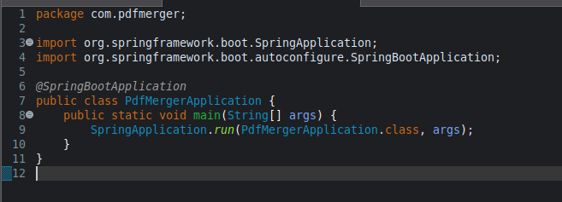

Details of PDFMergerApplication.java

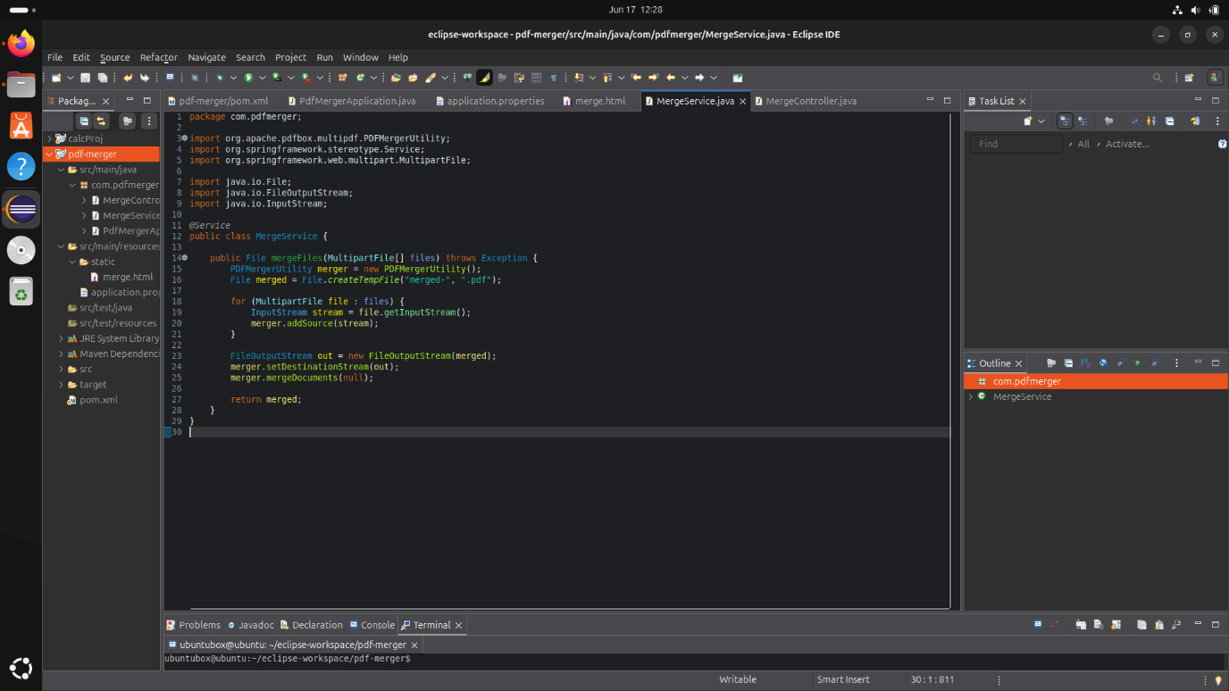

Details of MergerService.java

Step 3: Building the Java Application using Maven

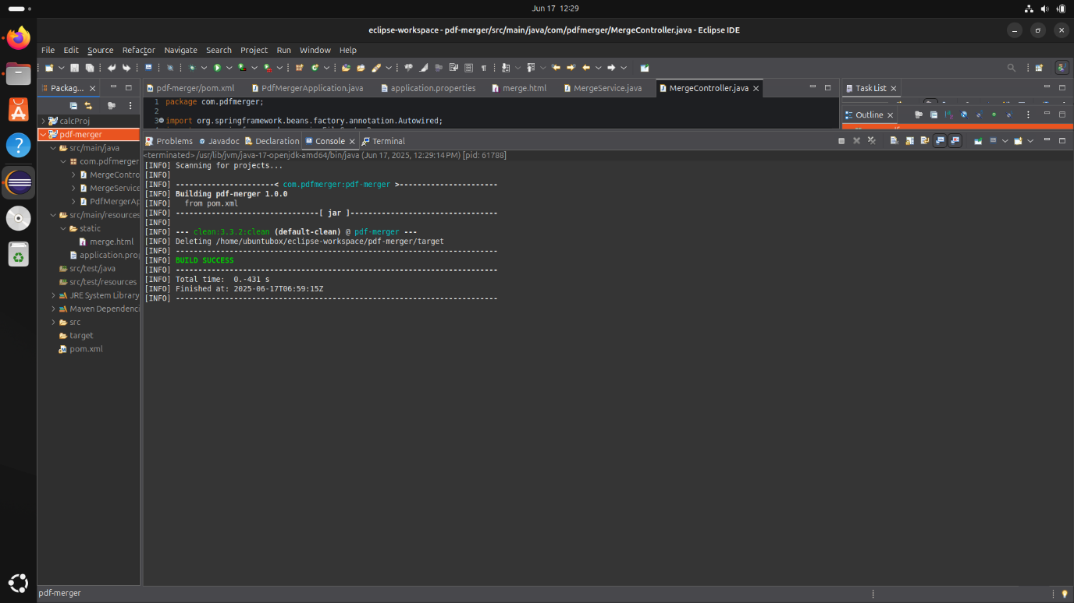

Running mvn clean

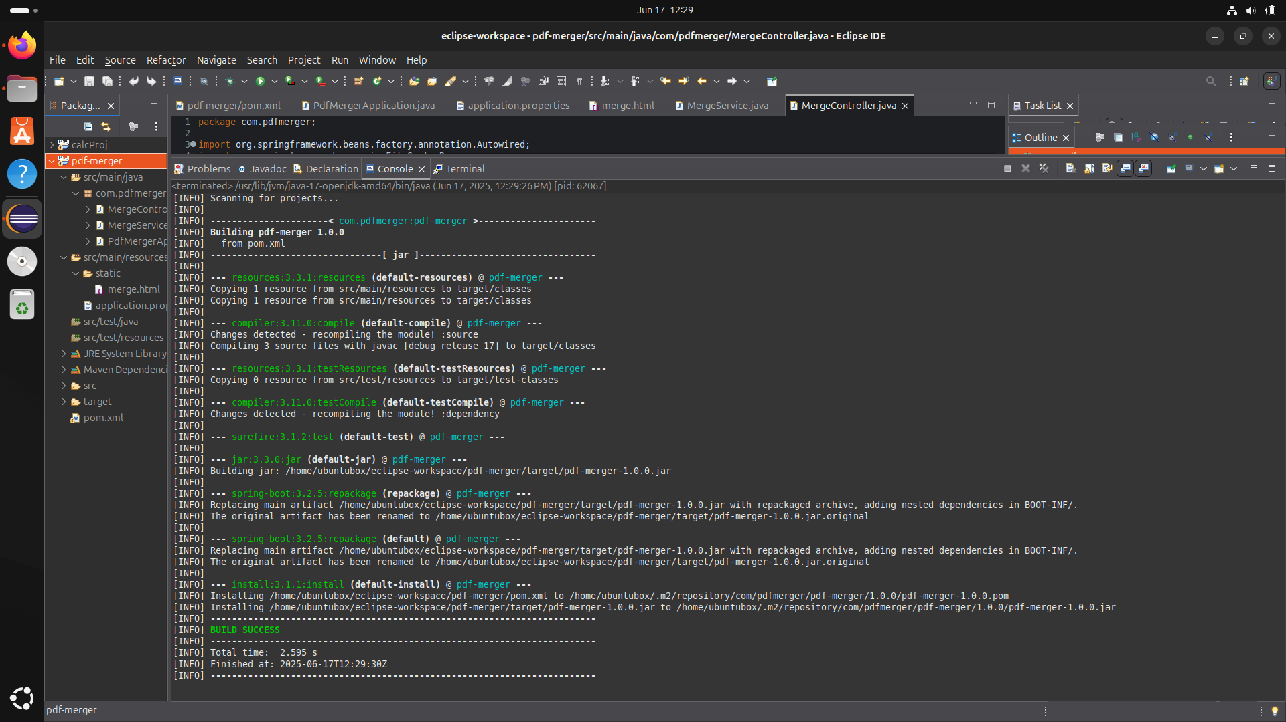

Running mvn build

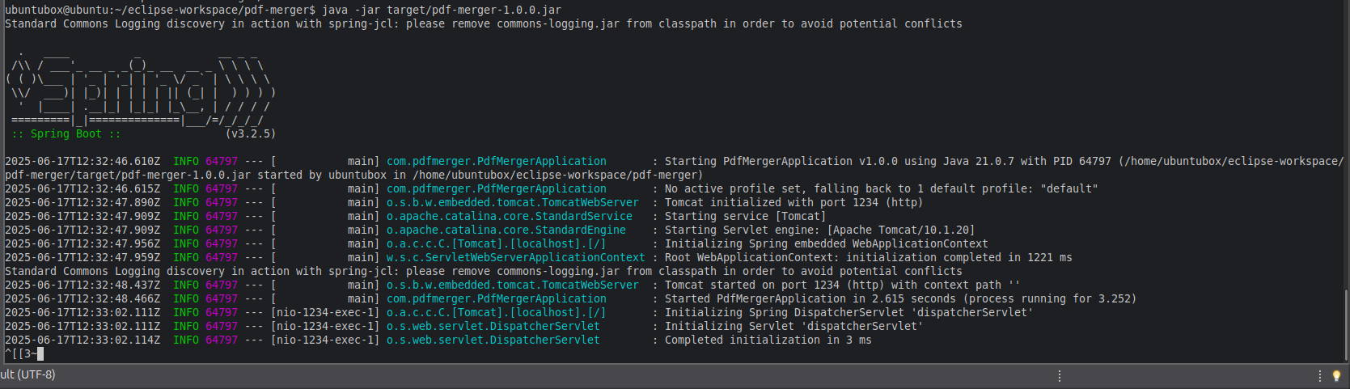

Running the jar file created in previous step

Step 4: Demo of the website

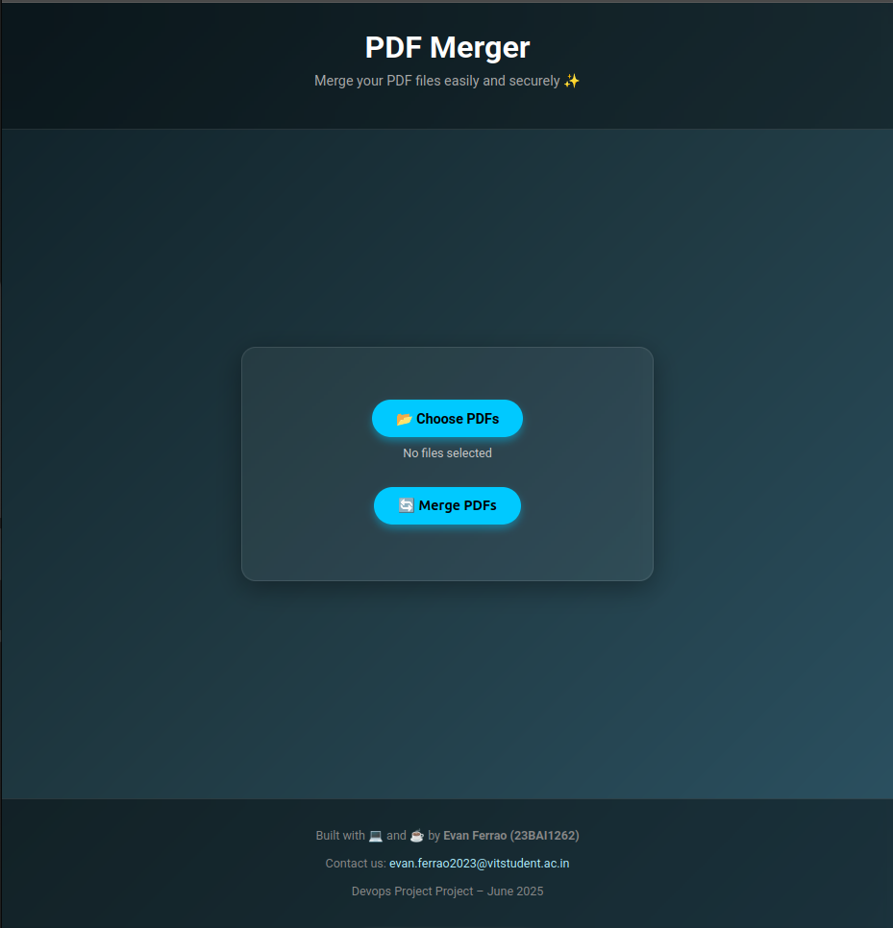

Screnshot of website running on localhost port 1234

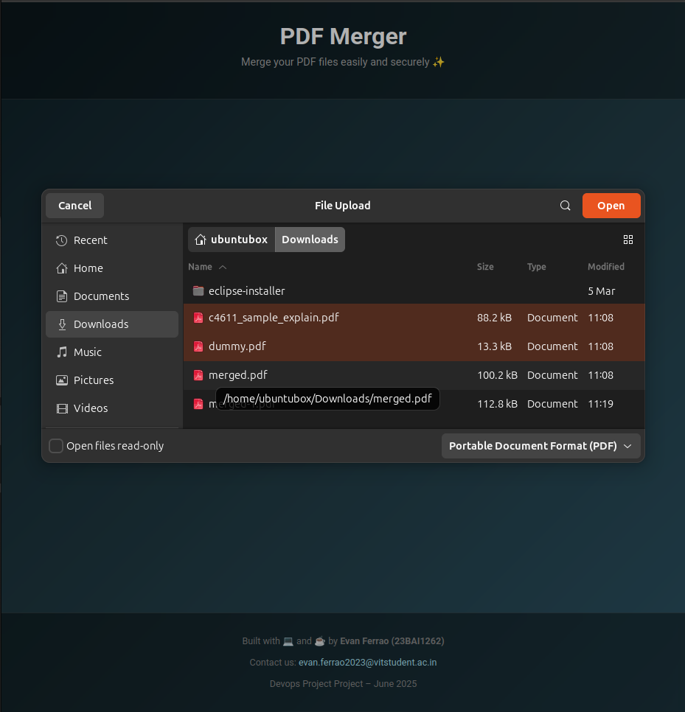

Selecting files for upload

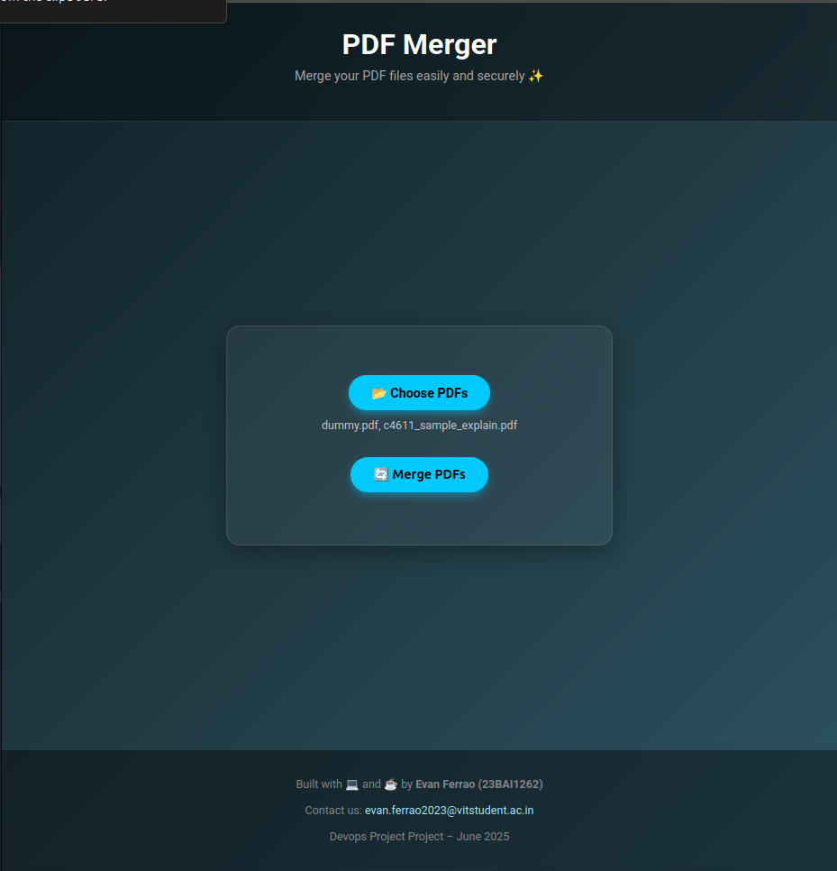

Files loaded in the program website

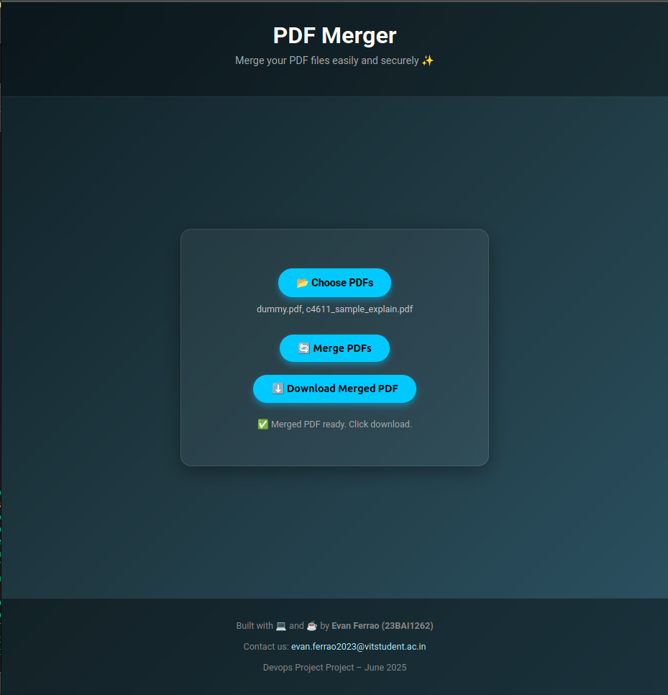

Merge Button Pressed => Output file generated



Output file downloaded to computer

Step 5: Setting up deployment with the help of puppet

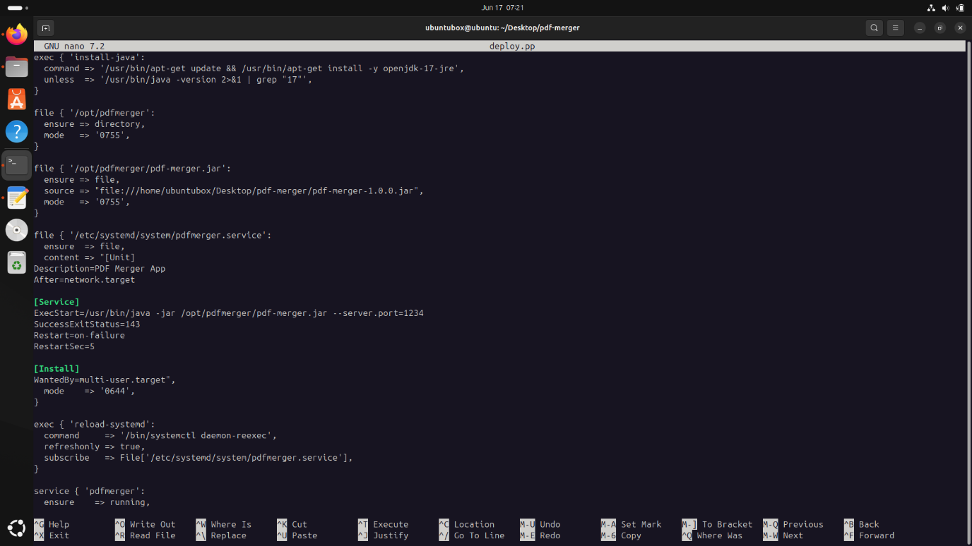

Initial file for deploy.pp for use with puppet

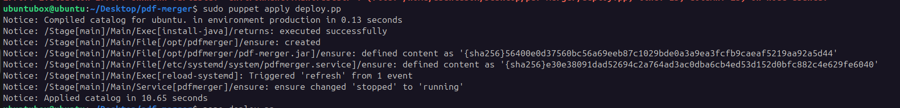

Applying the puppet file

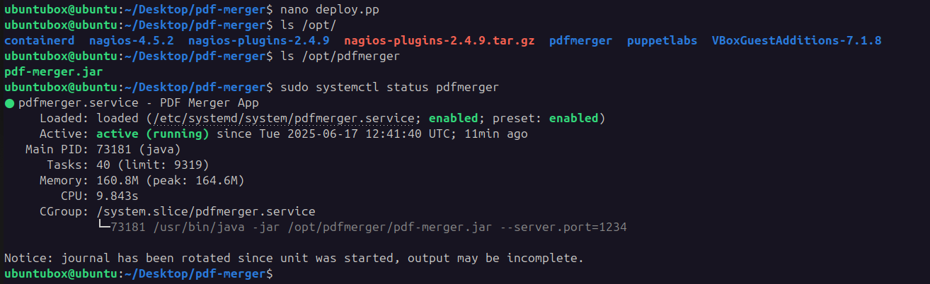

Checking the status of the puppet deployment

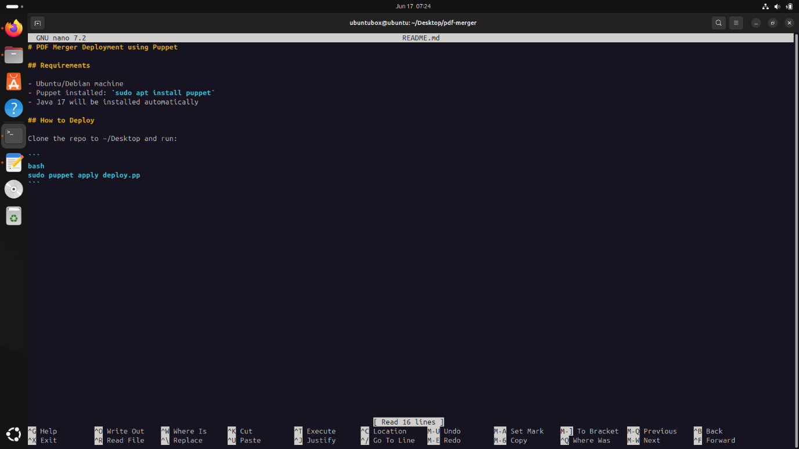

Creating Readme for puppet

Step 6: Git for version control of out PDF Merger Website Application

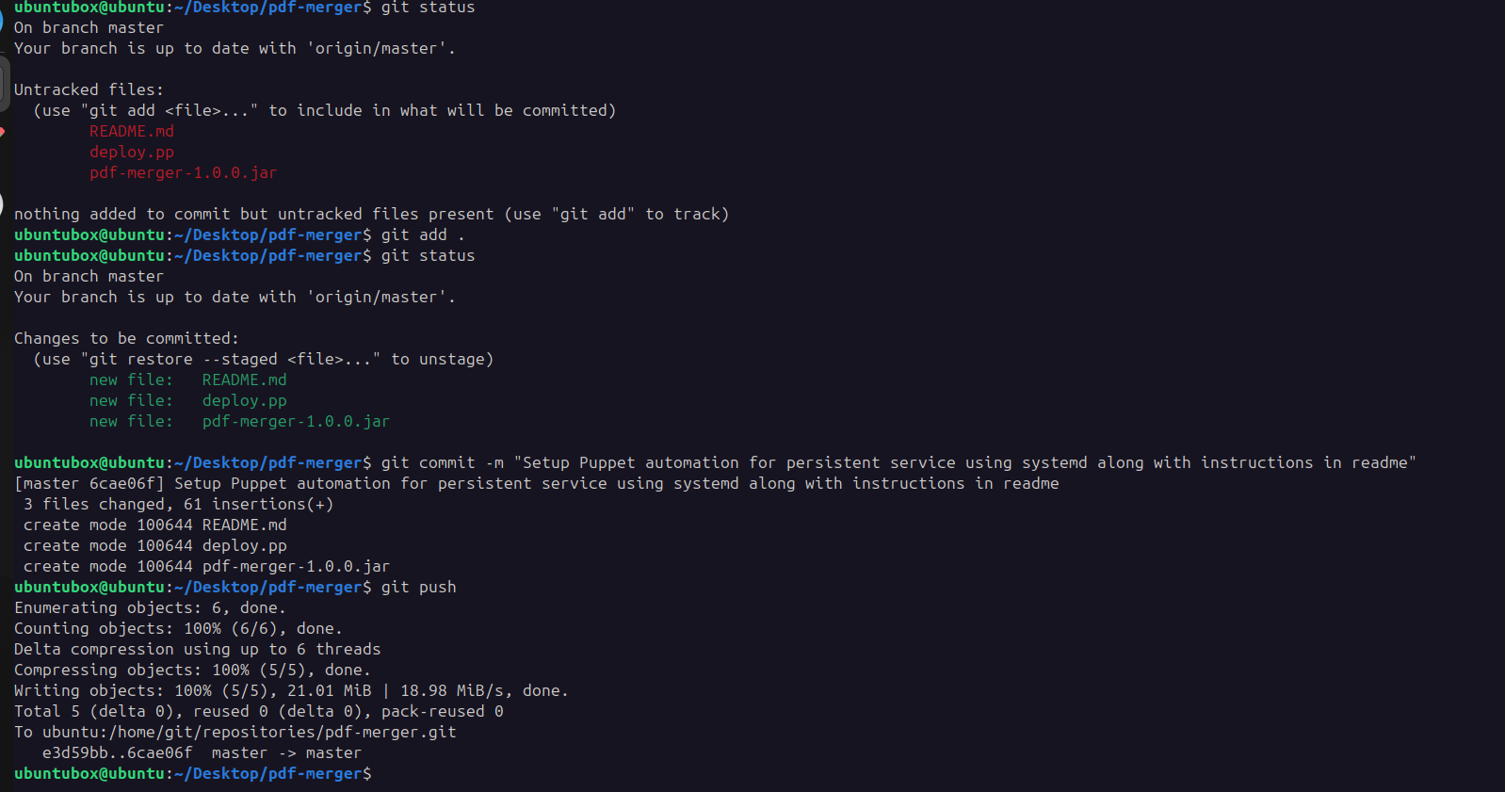

Add files and commit the changes

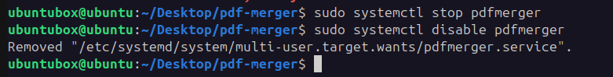

Disable existing pdfmerger service

Step 7: Docker Setup for deployment through Dockerfile

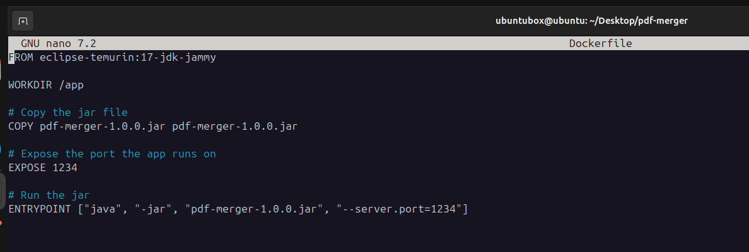

Initial Dockerfile for the deployment

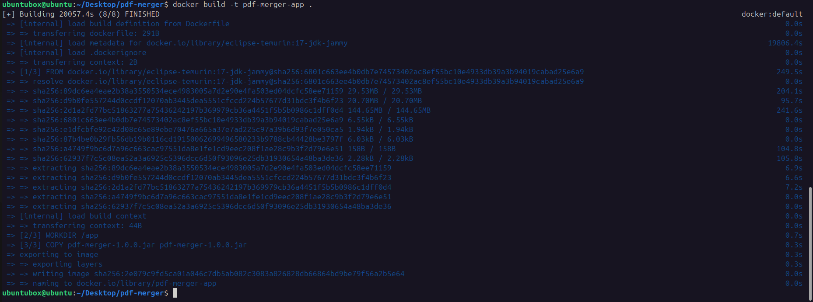

Building the docker container



Running the docker container

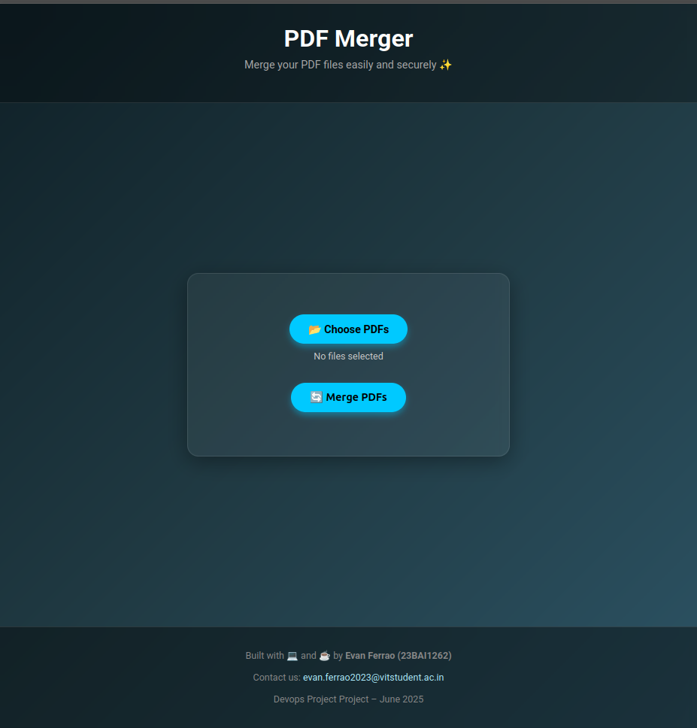

Output of docker container running. Thus we have successfully run the pdf merger application using docker container

Step 8: Ansible Playbook setup for advanced configuration of docker container and automation CI

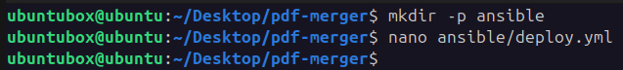

Making ansible folder

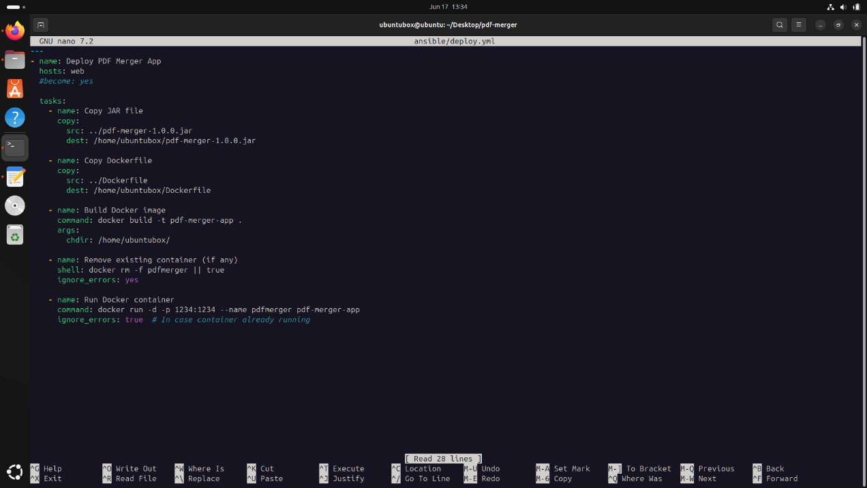

Ansible playbook deploy.yml

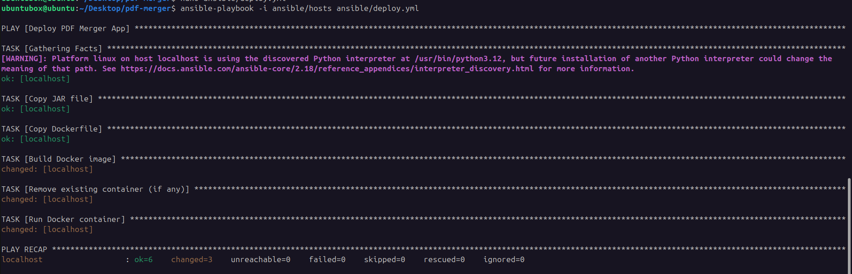

Running ansible-playbook

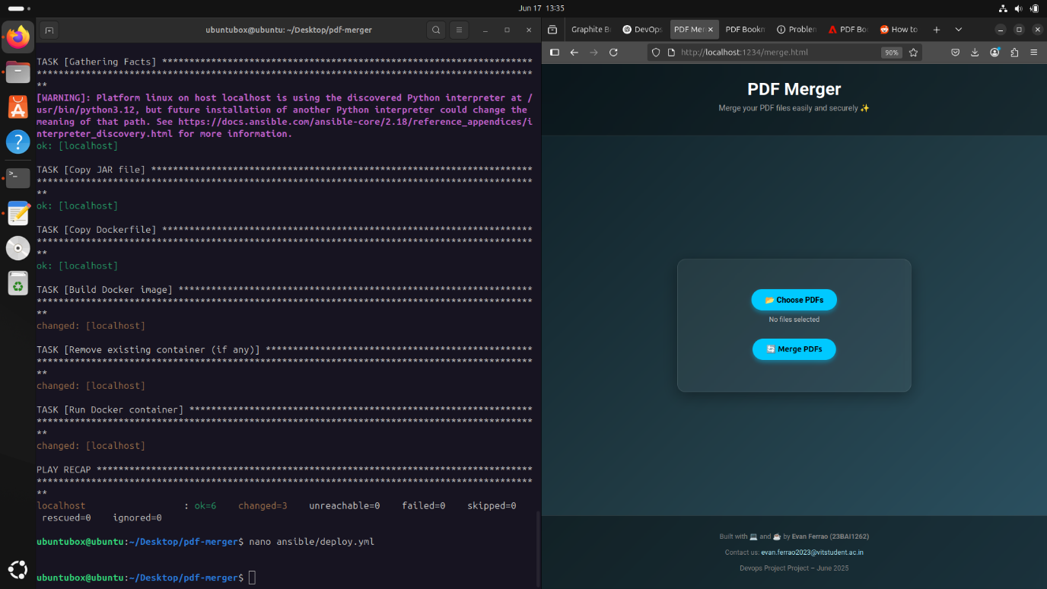

Deployment of website using ansible playbook tasks. Thus we have deployed the website using ansible playbook.

Step 9: Jenkins setup for CI

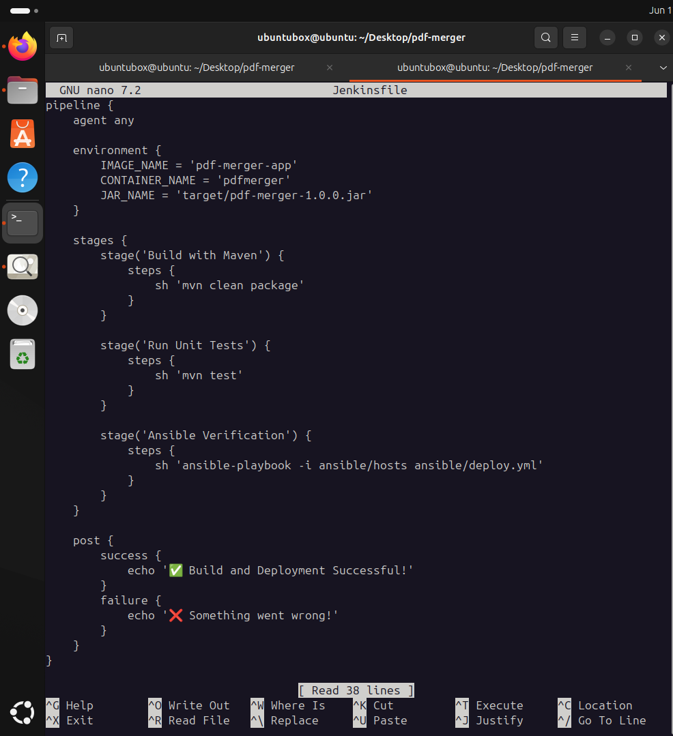

Initial Jenkins config file

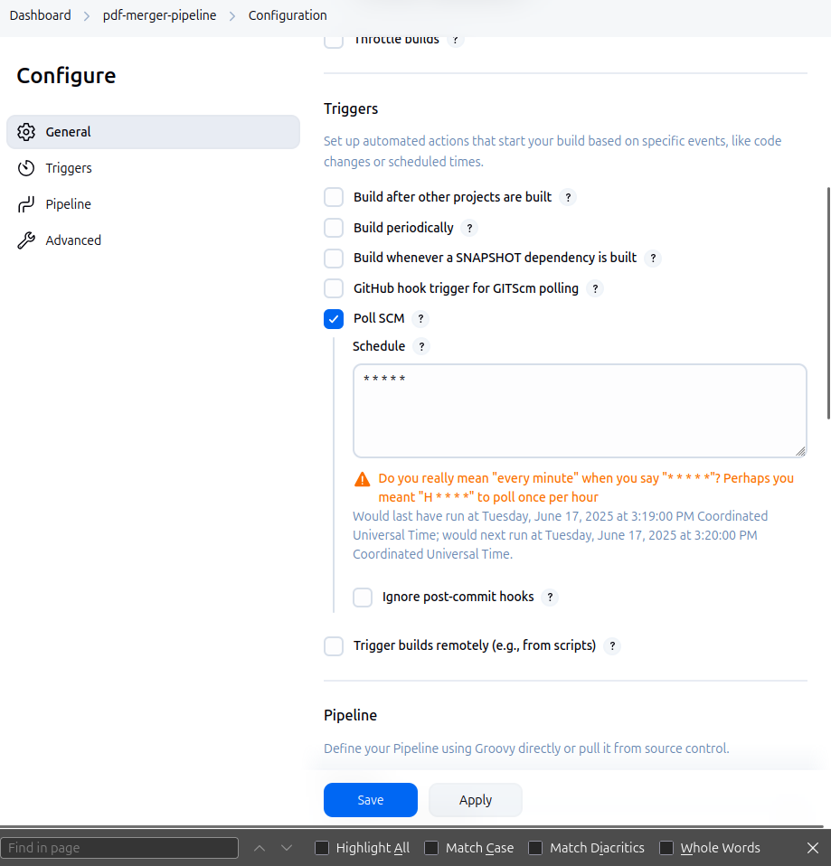

Configuring Jenkins for building on new commit to repository

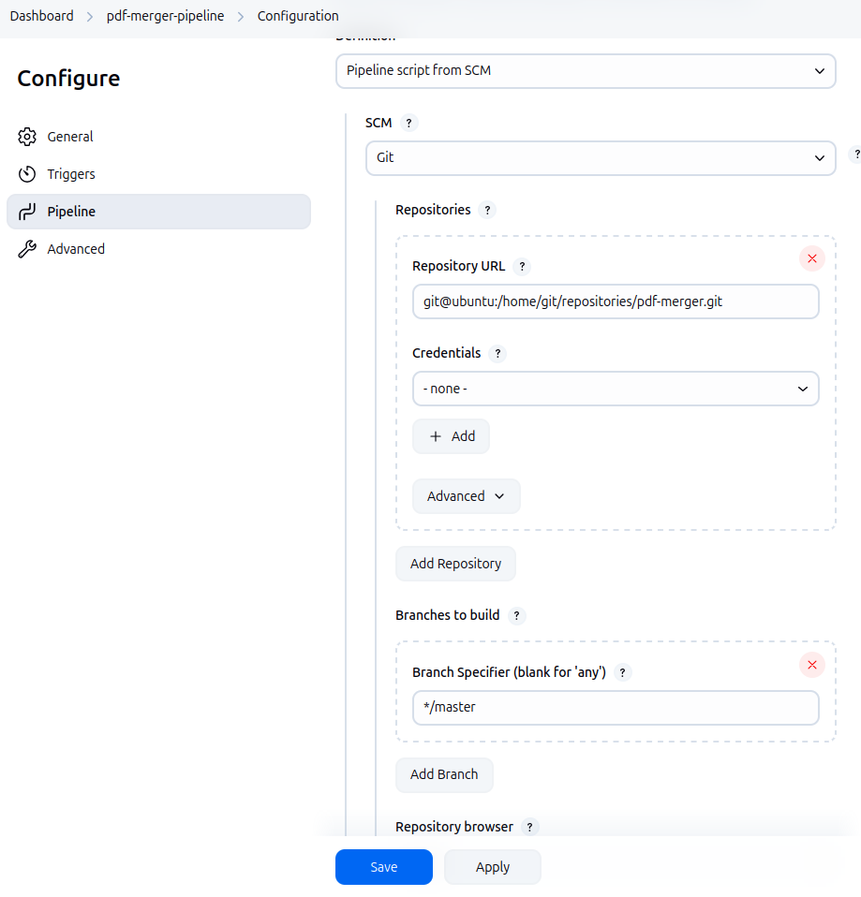

Linking the local repository on the @git user of the virtual machine

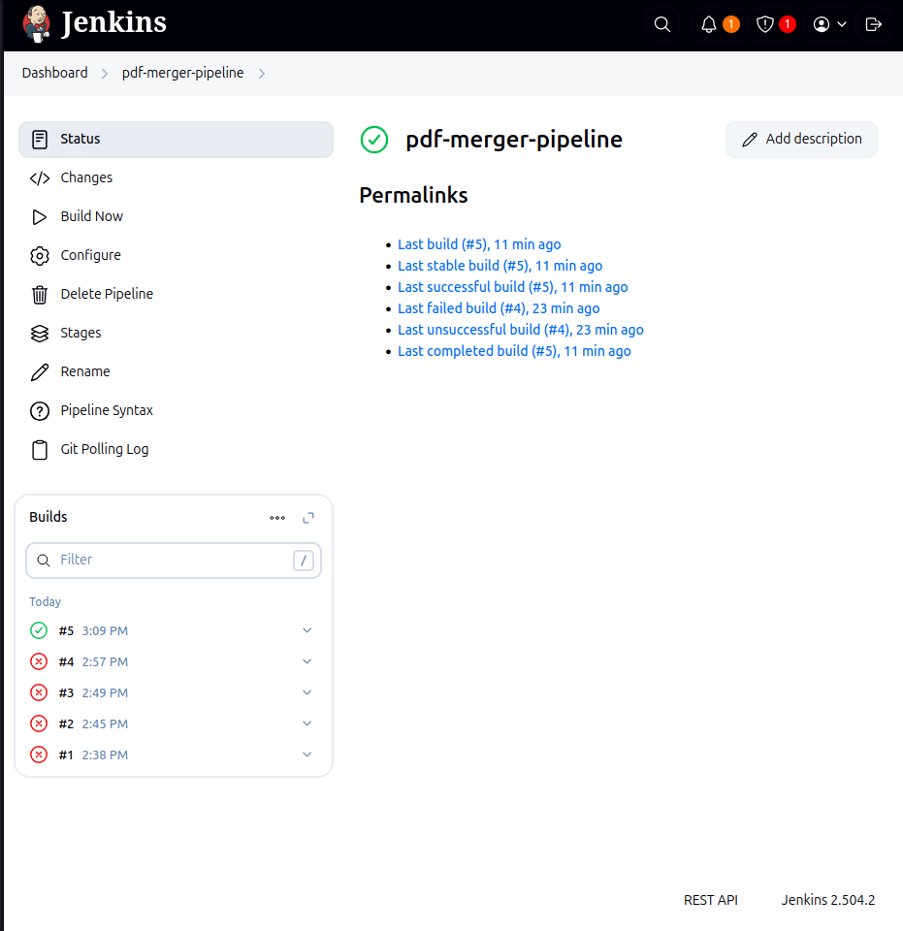

Successfully setup Jenkins CI

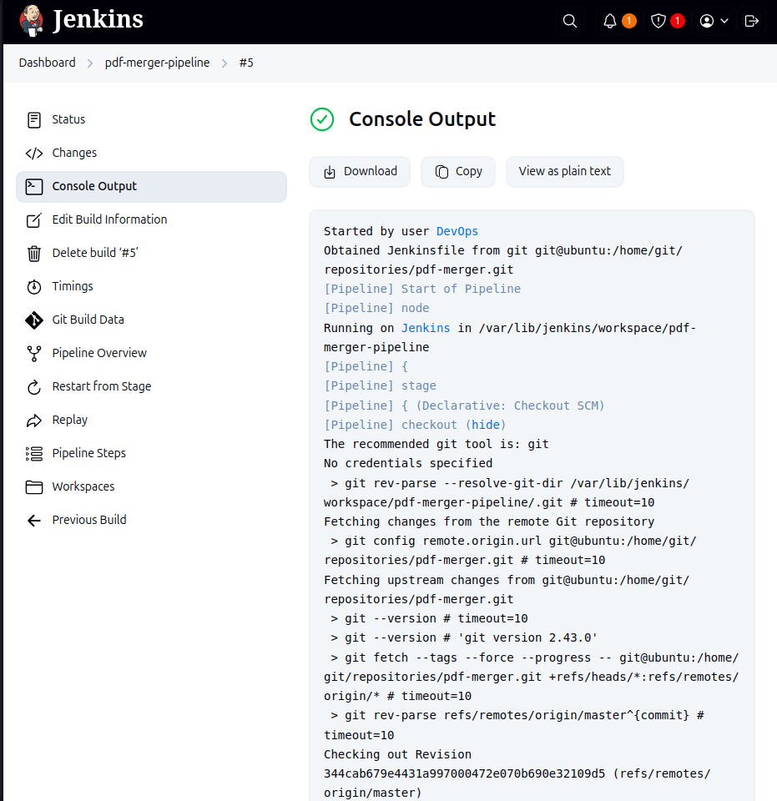

Jenkins CI build output run

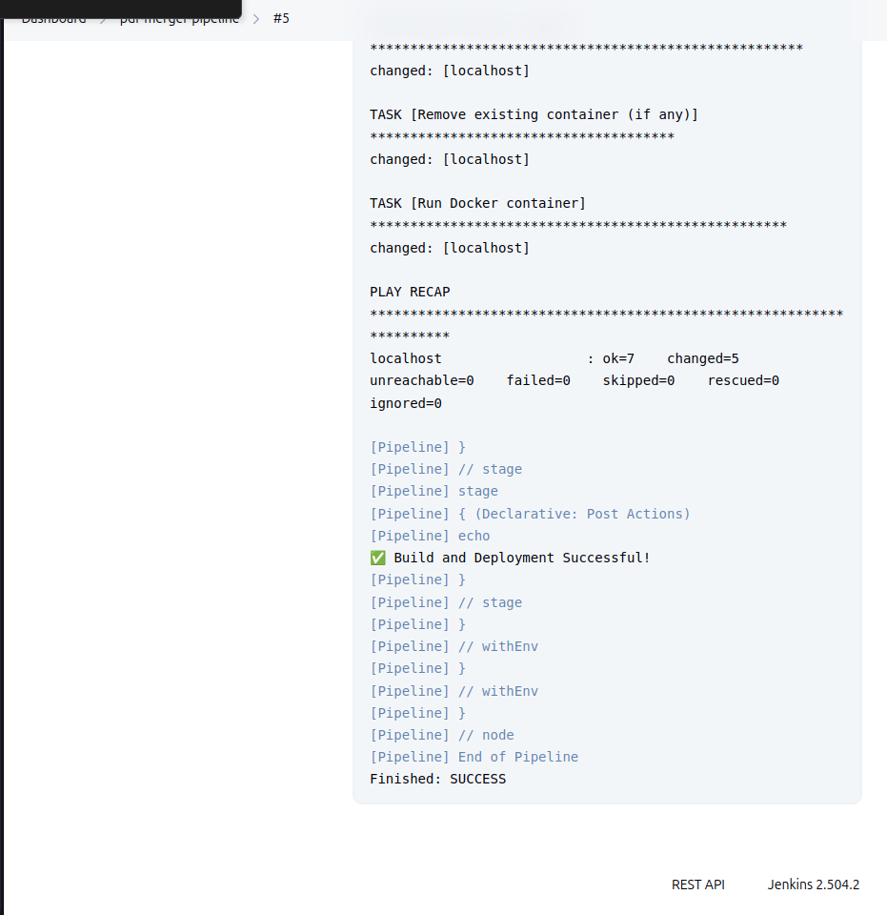

Successful deployment using Jenkins which is triggered on push to @master branch of the local git repository

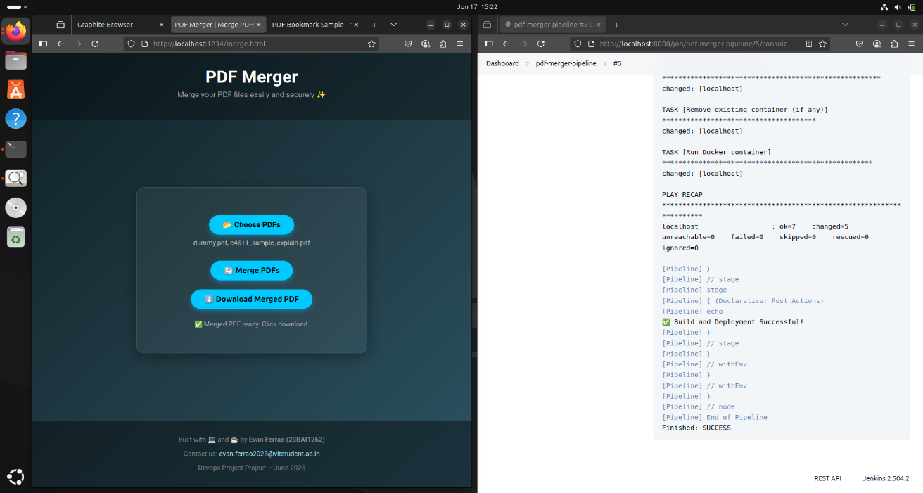

Deployment of website automated using Jenkins CI on every push

Step 10: Setting up graphite and Grafana for monitoring the usage and showing the statistics of websites.

We will be monitoring stats like

1. PDF’s merged
2. PDF’s failed to merge
3. PDF merge queue
4. CPU resources
5. RAM utilization

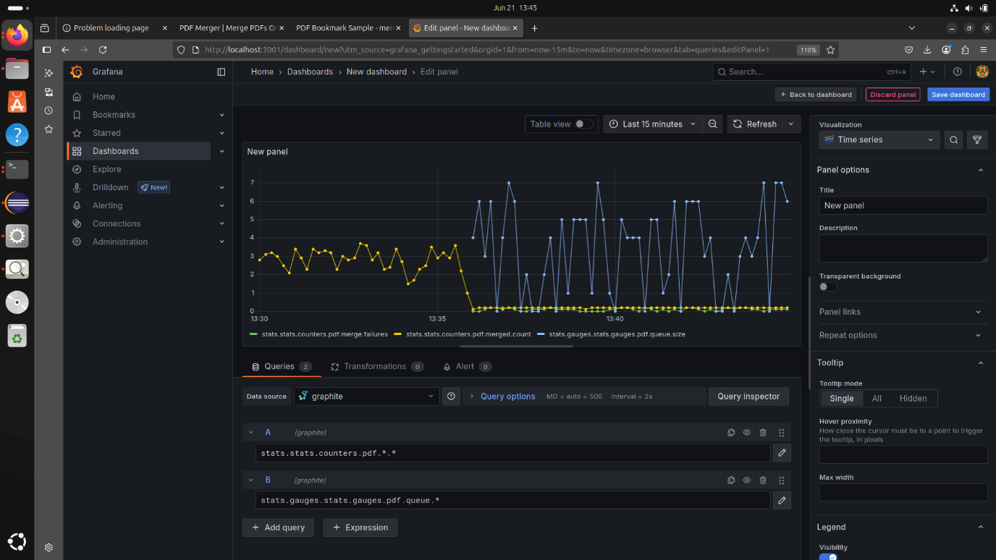

PDF Merge Failures

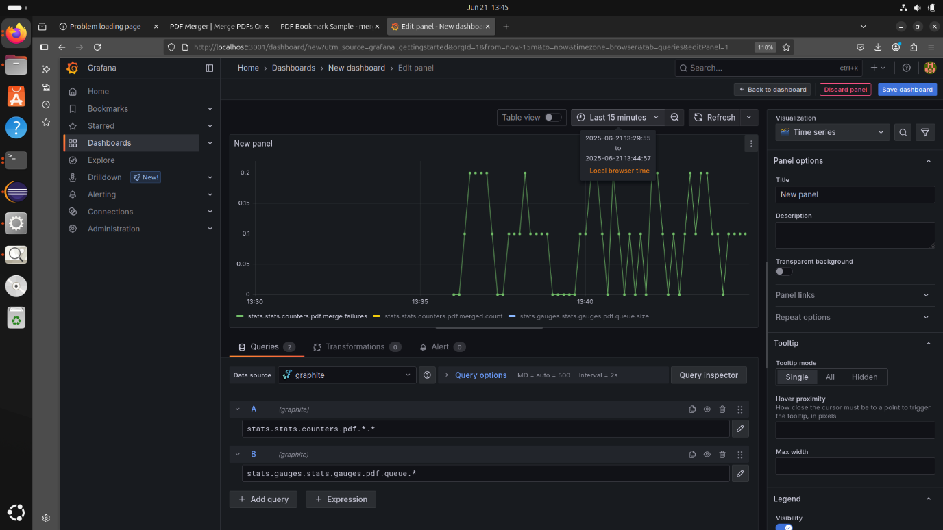PDF Merge count

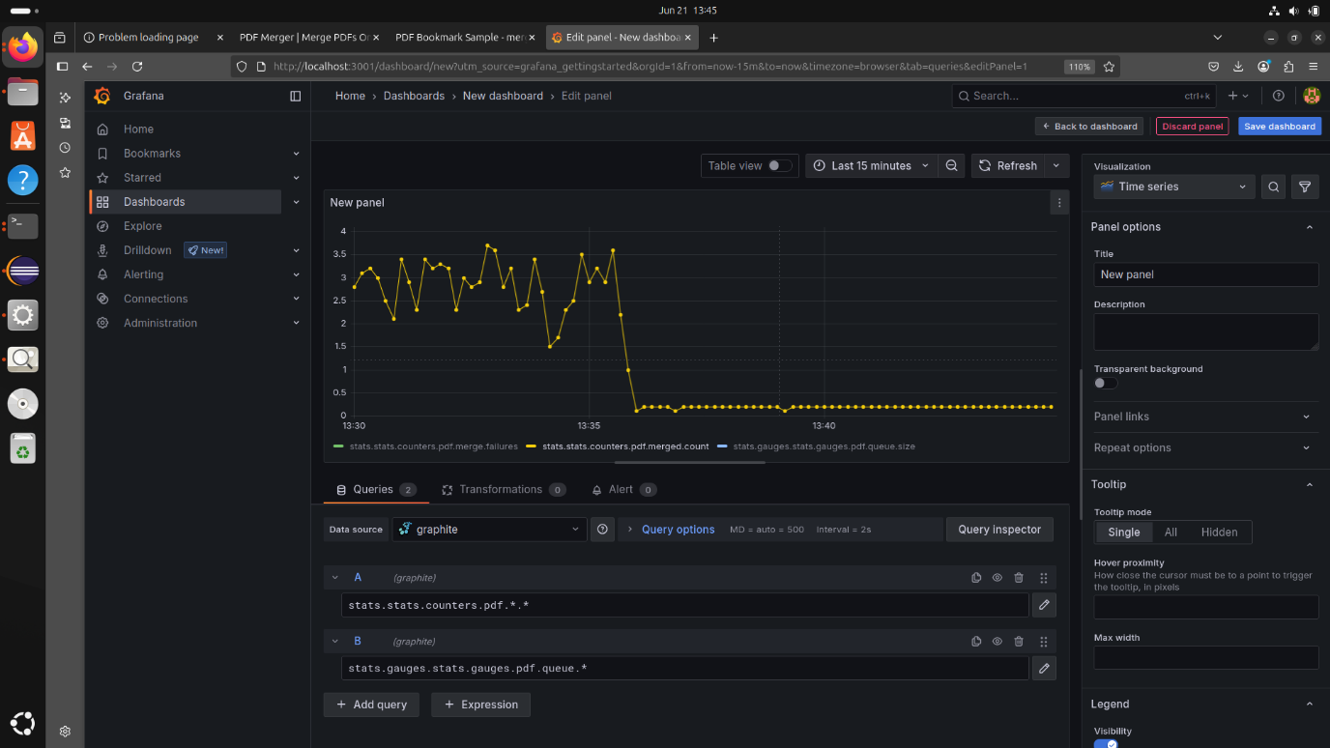

PDF Merge count (when idle)

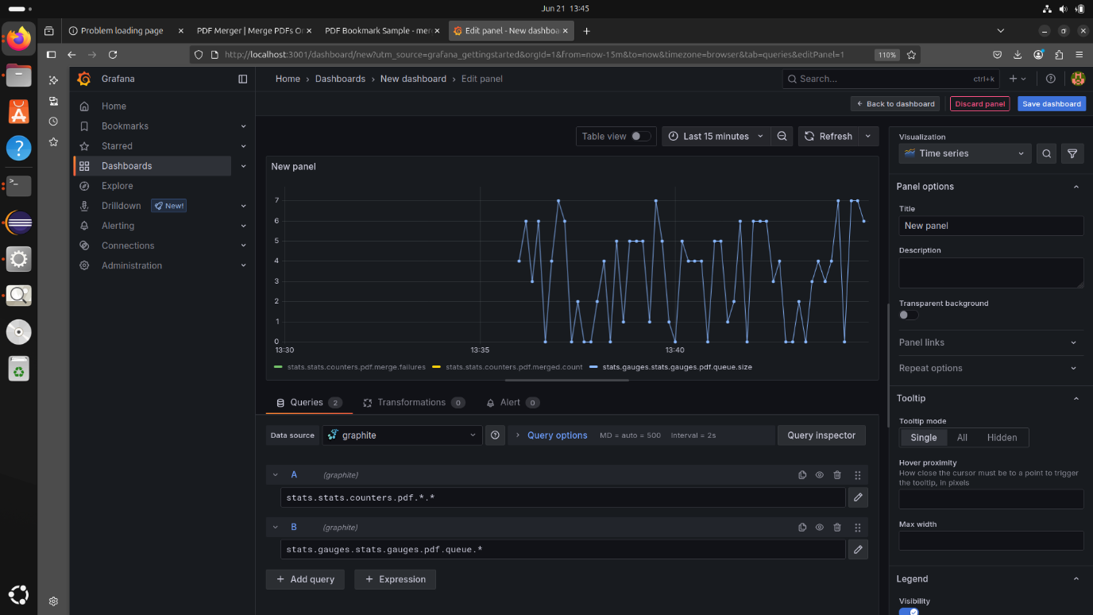

PDF Merge queue size (API Call Queue)

Source Code for the project can be found at GitHub Link: <https://github.com/evanferrao/devops-project-pdf-merger>

Demo website can be found at: DEMO WEBSITE: <https://devops-project-pdf-merger.onrender.com/merge.html>

Thank You